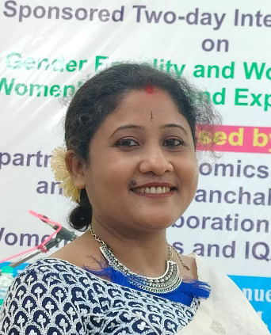
Curriculum Vita

Smt. Moumita Chatterjee
State Aided College Teacher in Chemistry
Email: chatterjeemoumita9851@gmail.com
Date of Birth: 18-01-1989
Contact: 8972061781
About:
- Moumita Chatterjee is a permanent resident of 36A/43, B. G ROAD, PO- MOKDUMPUR, DIST-MALDA, PIN -732103, West Bengal.
- She has completed B.sc (HONS) in Chemistry from Rampurhat College affiliated to The University of Burdwan in 2011.
- She has completed M.sc in Chemistry from Sidoo Kanhu Murmu University in 2015.
- She has joined Chanchal College in Malda as a Guest Lecturer on 08.12.2018 and continued her service as a State Aided College Teacher till now.

